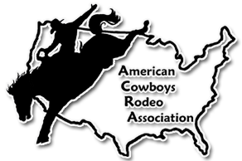
American Cowboys Rodeo Association

www.acrarodeo.com
Phone 479-238-3035

American Finals Rodeo January 29-31, 2026
Tulsa, Oklahoma
Trade Show Booth Reservation Form

Name: _______________________________________________________________________________________________

Address: _____________________________________________________________________________________________

State: _______ Zip: ____________ Email: ____________________________________Phone: ________________________

Description of Products or Services: _______________________________________________________________________
_____________________________________________________________________________________________________
Exhibit Information

10 x 10 = $200.00 Each additional 10 x 10 = $150.00
Electric - $40.00 (optional), Booth space includes 2 All Session Passes

Total for Booth Space(s) $______________________________________

Electric $______________________________________

Additional Rodeo Tickets (all Session) $___________40.00________________

Total Enclosed $______________________________________

Circle method of Payment: Visa Mastercard Check Money Order

In an effort to keep your credit card secure, should you choose that method of payment, we ask that you call the AFR Tradeshow Coordinator & give her the credit card information over the phone rather than sending it through the mail.
Contact Kari Hutchins @ 479-238-3035 for credit card payments.
Return form with payment to: ACRA, PO Box 1 Siloam Springs, AR 72761
Booths will be assigned on a first come first serve basis. AFR Tradeshow Coordinator reserves the right to alter floor plan as deemed necessary. Exhibitors will be notified of booth location upon receipt of reservation and payment in full. No refunds after application and payment are submitted. No sharing of booth spaces. Email tradeshow forms to acrarodeo@yahoo.com

